|  |
| --- |
| <Accident Data Analysis Tool> Executive Summary |
| Harmol Kaur and Jigme Yeshey2810ICT Software Technologies |

# Abstract

# This executive summary encapsulates a comprehensive 12-month analysis of accident data from the Victoria State Accident dataset, spanning from January 2014 to January 2015. The study leverages the Accident Data Analysis Tool to uncover critical insights into various aspects of accidents and their impact on road safety. It aims to empower policymakers, safety advocates, and stakeholders with the knowledge required to foster safer roads and save lives.

# Introduction

# The following report offers a comprehensive analysis of accident data derived from the Victoria State Accident dataset, covering a period from January 2014 to January 2015. The Victorian state accident dataset has been used in the Accident Data Analysis Tool to provide valuable insights into various factors of accidents, ultimately contributing to informed decision-making and enhanced safety measures.

# **Analysis 1 <Accident Analysis>**

* This analysis presents a comprehensive overview of accidents within the Victorian State Accident Dataset. The dataset encompasses a wide array of accident-related information, including but not limited to:

|  |  |
| --- | --- |
| * **OBJECTID** | * **ACCIDENT_TIME** |
| * **ACCIDENT_NO** | * **ALCOHOLTIME** |
| * **ABS_CODE** | * **ACCIDENT_TYPE** |
| * **ACCIDENT_STATUS** | * **LIGHT_CONDITION** |
| * **ACCIDENT_DATE** | * **SEVERITY** |
| * **SPEED_ZONE** | * **RUN_OFFROAD** |
| * **REGION_NAME** | * **ALCOHOL_RELATED** |

The following is the figure showing a section of the chart. As observed from the chart, the total number of accidents in the dataset amounts to 11,710. This comprehensive dataset offers a valuable resource for in-depth analysis and insights into accident patterns, contributing to informed decision-making and safety measures.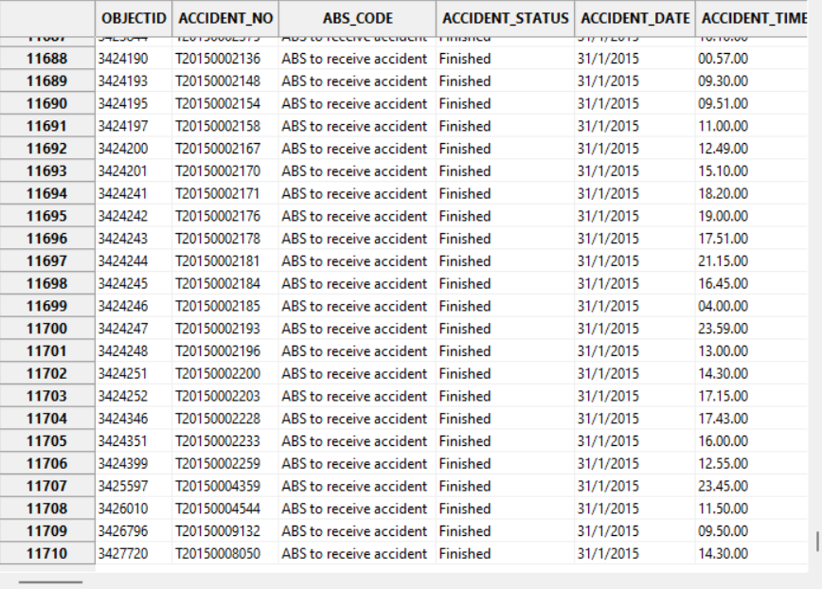

# **Analysis 2 <Hourly Accident Trends>**

This section provides an in-depth analysis of the average number of accidents occurring during specific hours of the day over a one-year period, from January 2014 to January 2015. The analysis was conducted to identify patterns in the frequency of accidents throughout the day. The key findings are as follows:

1. **Peak Hour of Accidents:**

The data reveals a notable peak in accident frequency at 1700 hours (5:00 PM). During this hour, the average number of accidents is at its highest.

1. **Lowest Average Occurs Early Morning:**

The lowest average of accidents is observed during the early morning hours, specifically between 0200 and 0300 (2:00 AM - 3:00 AM). This period experiences the least number of accidents.

1. **Year-Long Consistency:**

An intriguing observation is that the hourly patterns of accidents remained remarkably consistent throughout the entire year. This consistency is evident despite a slight decline in the overall frequency of accidents from the beginning of 2014 to the end.

1. **Hourly Patterns:**

The data illustrates that the number of accidents at night (from 2200 to 0400) ranges from 3 to 4 on average per hour. In contrast, the morning hours (from 0700 to 0900) see an increase in accident frequency, reaching its peak at around 1700 hours. Afterward, the accident frequency gradually declines.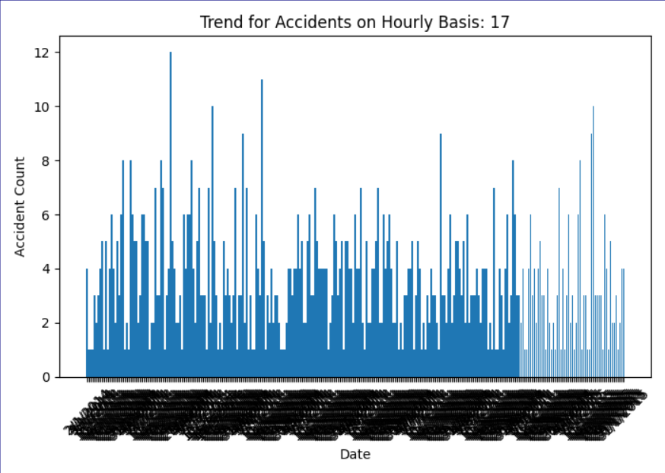

*Figure: - Hourly Trends for accidents at 1700*

*Figure: - Hourly Trends for accidents at 0200*

This analysis provides valuable insights into the temporal distribution of accidents, offering a clear understanding of peak and off-peak hours. Such knowledge is crucial for informed decision-making in traffic management, safety planning, and resource allocation.

Analysis 3 <Accidents analysis by different accident types>

In this analysis, we delve deeper into accidents by categorizing them based on their types. Each accident type presents a unique set of circumstances and conditions. Here are the key findings for each accident type:

**1. Accident Type: Struck Pedestrian**

* **Total Number of Accidents: 1006**
* **Time of Occurrence:** Struck pedestrian accidents predominantly took place during the daytime, with a notable number occurring at dusk and a few at night. This suggests that pedestrian safety measures during daylight hours should be a priority.
* **Location:** Most of these accidents happened at intersections, indicating the need for improved pedestrian safety infrastructure at these locations. The accidents were more common on local or arterial roads, highlighting the importance of addressing pedestrian safety on these road types.

**2. Accident Type: Collision with Vehicle**

* **Total Number of Accidents: 7296**
* **Time of Occurrence:** Accidents involving a collision with a vehicle primarily occurred during the day. This underscores the significance of daytime road safety measures, including driver awareness and adherence to traffic rules.
* **Location:** These accidents were concentrated on local or arterial roads, emphasizing the need for improved safety measures and enforcement on these road segments.

**3. Accident Type: Collision with Fixed Object**

* **Total Number of Accidents: 1846**
* **Light Conditions:** A considerable portion of these accidents occurred in dark street conditions or in the dark with streetlights on. This highlights the importance of well-lit roads, especially on local arterial roads.
* **Location:** Most accidents in this category took place on local arterial roads. This suggests that safety measures should focus on reducing collisions with fixed objects on these road types.

**4. Accident Type: No Collision, No Object Struck**

* **Total Number of Accidents: 683**
* **Time of Occurrence:** These accidents predominantly occurred during the day, suggesting a need for safety measures during daytime driving.
* **Location:** They mainly took place on local roads, highlighting the importance of safety initiatives on these road segments.

**5. Accident Type: Struck Animal**

* **Total Number of Accidents: 127**
* **Light Conditions:** Accidents in this category mainly occurred in dark conditions with no streetlights, as well as during dawn or dusk. Safety measures should focus on these specific light conditions.
* **Location:** These accidents were concentrated in the "STATE_DIV_NAME" country region on local roads, pointing towards a specific area where safety measures can be enhanced.

**6. Accident Type: Vehicle Overturned, No Collision**

* **Total Number of Accidents: 588**
* **Time of Occurrence:** Most of these accidents occurred during the day, at dusk, or dawn. This highlights the importance of safety measures addressing daytime and transitional light conditions.
* **Circumstances:** Vehicles involved in these accidents mostly ran off the road and were on arterial highways. Road design and safety measures should consider these factors.

**7. Accident Type: Collision with Some Other Object**

* **Total Number of Accidents: 93**
* **Circumstances:** These accidents did not involve vehicles running off the road and primarily occurred during the day. This highlights the need for safety measures addressing daytime driving conditions.
* **Location:** They mainly occurred on local and arterial roads, with a concentration in rural Victoria, suggesting that specific rural safety measures may be beneficial.

**8. Accident Type: Fall from or in Vehicle**

* **Total Number of Accidents: 63**
* **Light Conditions:** These accidents predominantly occurred in dark or at dusk. Safety measures should focus on improving visibility during these times.
* **Location:** These accidents primarily occurred in the Melb_Urban " area on local roads, indicating the need for urban safety measures.

**9. Other Accident Types**

* **Total Number of Accidents: 11**
* **Light Conditions:** These accidents mainly occurred during dusk or dawn. Safety measures should consider visibility during transitional light conditions.
* **Location:** Concentrated on local roads in the "Melb_Urban" area, highlighting the need for safety initiatives in this urban setting.

This detailed analysis of accidents by their specific types provides valuable insights into the circumstances, times, and locations where these incidents occur. These findings can inform the development of targeted safety measures and traffic management strategies tailored to each accident scenario. Such tailored approaches have the potential to enhance overall road safety and reduce the occurrence of accidents of different types.

# **Analysis 4 <Impact of Alcohol>**

The analysis conducted reveals a substantial and concerning pattern regarding the impact of alcohol on road accidents throughout the year. The findings are presented in the figure below:

*Figure: - Chart displaying trends in accidents during Alcohol time*

It is evident from this graph that the influence of alcohol on accidents was considerable. The frequency of accidents during periods associated with alcohol consumption reached a peak of approximately 35 accidents per day. Furthermore, the average daily accident counts consistently remained in the range of 10 to 25 accidents per day.

Despite fluctuations observed throughout the year, there is no noticeable decline in the number of accidents during times when alcohol consumption is prevalent. This sustained high accident rate during alcohol-related time periods underscores the significant and alarming impact of alcohol on the occurrence of road accidents.

These findings highlight the urgent need for comprehensive and targeted measures to address the issue of alcohol-related accidents. Such measures may include enhanced law enforcement, public awareness campaigns, and strategies to deter impaired driving. By focusing on mitigating the influence of alcohol on road safety, we can strive to reduce the occurrence of accidents and ultimately save lives on the road.

# **Analysis 5 <Frequency of Accident types>**

This analysis presents the trends for different accident types over time, as illustrated by the bar chart below:

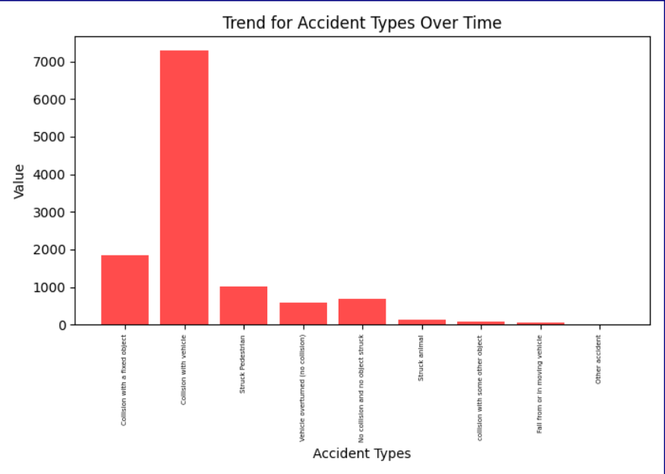*Figure: - Bar chart displays Accident types over time.*

The bar chart vividly depicts the frequency of various accident types observed during the specified time period. Notable findings from this analysis include:

* The most prevalent accident type was "Collision with Vehicle," with the number of incidents reaching approximately 7,000. This type of accident significantly outweighed others in terms of occurrence.
* Following next was the category of "Collision with a Fixed Object," with an observed count of approximately 2,000 accidents. Although this figure is lower than collisions with vehicles, it remains a substantial proportion of the total accidents.
* "Struck Pedestrian" constituted the third most frequent accident type, with an estimated count hovering around 1,000 incidents.
* The accident type "No Collision and No Object Struck" and "Vehicle Overturned" both exhibited similar counts, with approximately 800 occurrences each.
* The least common accident types were "Struck Animal," "Collision with Some Other Object," "Fall from or in the Vehicle," and a few other categories.

These findings shed light on the distribution of accident types, emphasizing the prominence of certain types over others. Such insights can inform safety measures, resources allocation, and strategies to reduce the prevalence of accidents, especially those involving collision with vehicles, which appear to be the most frequent and pressing concern.

Top of Form